|  |  |
| --- | --- |
| **Building Name** | Click or tap here to enter text. |
| **Address** | Click or tap here to enter text. |
| **Date** |  |

|  |
| --- |
| **Building Description** |
| Click or tap here to enter text. |
| **Outdoor Evacuation Location** |
| Click or tap here to enter text. |
| **Critical or Hazardous Operations** |
| Click or tap here to enter text. |
| **Typical Building Occupancy** |
| Click or tap here to enter text. |
| **Additional Information** |
| Click or tap here to enter text. |

Building Photo



Mark the outdoor evacuation locations on the photo above

**Building Supervisor / Designee Emergency Contact Information**

|  |  |  |
| --- | --- | --- |
| **Name** | **Cell Phone Number** | **Office Number** |
| Click or tap here to enter text. | Click or tap here to enter text. | Click or tap here to enter text. |
| Click or tap here to enter text. | Click or tap here to enter text. | Click or tap here to enter text. |
| Click or tap here to enter text. | Click or tap here to enter text. | Click or tap here to enter text. |
| Click or tap here to enter text. | Click or tap here to enter text. | Click or tap here to enter text. |
| Click or tap here to enter text. | Click or tap here to enter text. | Click or tap here to enter text. |

**Building Hazardous or Critical Operation**

|  |  |  |  |  |
| --- | --- | --- | --- | --- |
| **Operation** | **Room** | **Department** | **Responsible Person** | **Phone** |
| Click or tap here to enter text. | Click or tap here to enter text. | Click or tap here to enter text. | Click or tap here to enter text. | Click or tap here to enter text. |
| Click or tap here to enter text. | Click or tap here to enter text. | Click or tap here to enter text. | Click or tap here to enter text. | Click or tap here to enter text. |
| Click or tap here to enter text. | Click or tap here to enter text. | Click or tap here to enter text. | Click or tap here to enter text. | Click or tap here to enter text. |
| Click or tap here to enter text. | Click or tap here to enter text. | Click or tap here to enter text. | Click or tap here to enter text. | Click or tap here to enter text. |
| Click or tap here to enter text. | Click or tap here to enter text. | Click or tap here to enter text. | Click or tap here to enter text. | Click or tap here to enter text. |
| Click or tap here to enter text. | Click or tap here to enter text. | Click or tap here to enter text. | Click or tap here to enter text. | Click or tap here to enter text. |
| Click or tap here to enter text. | Click or tap here to enter text. | Click or tap here to enter text. | Click or tap here to enter text. | Click or tap here to enter text. |
| Click or tap here to enter text. | Click or tap here to enter text. | Click or tap here to enter text. | Click or tap here to enter text. | Click or tap here to enter text. |
| Click or tap here to enter text. | Click or tap here to enter text. | Click or tap here to enter text. | Click or tap here to enter text. | Click or tap here to enter text. |
| Click or tap here to enter text. | Click or tap here to enter text. | Click or tap here to enter text. | Click or tap here to enter text. | Click or tap here to enter text. |
| Click or tap here to enter text. | Click or tap here to enter text. | Click or tap here to enter text. | Click or tap here to enter text. | Click or tap here to enter text. |
| Click or tap here to enter text. | Click or tap here to enter text. | Click or tap here to enter text. | Click or tap here to enter text. | Click or tap here to enter text. |
| Click or tap here to enter text. | Click or tap here to enter text. | Click or tap here to enter text. | Click or tap here to enter text. | Click or tap here to enter text. |

**BUILDING COMMAND TEAM**

Building Command Team (BCT) is the decision making/incident evaluation team for the building. This Team should consist of senior administrator(s), building supervisor(s) and maintenance person(s) if assigned to that building. This team should have an interior designated meeting area, where emergency incident information is directed (team members should be notified and assembled here to assess the situation). The University Police Department and any other University support departments for this incident should meet the BCT at this location. IN CASE OF IMMEDIATE EVACUATION, the BCT should also have a designated exterior meeting area. BCT should always be looking for any first responders (Police, Fire, EMS) and integrate them into the decision-making process.

|  |  |  |  |
| --- | --- | --- | --- |
| **Name & Title** | **Department** | **Cell Phone** | **Room** |
| Click or tap here to enter text. | Click or tap here to enter text. | Click or tap here to enter text. | Click or tap here to enter text. |
| Click or tap here to enter text. | Click or tap here to enter text. | Click or tap here to enter text. | Click or tap here to enter text. |
| Click or tap here to enter text. | Click or tap here to enter text. |  | Click or tap here to enter text. |
| Click or tap here to enter text. | Click or tap here to enter text. | Click or tap here to enter text. | Click or tap here to enter text. |
| Click or tap here to enter text. | Click or tap here to enter text. | Click or tap here to enter text. | Click or tap here to enter text. |
| Click or tap here to enter text. | Click or tap here to enter text. | Click or tap here to enter text. | Click or tap here to enter text. |
| Click or tap here to enter text. | Click or tap here to enter text. | Click or tap here to enter text. | Click or tap here to enter text. |

**Record of Change**

|  |  |  |  |
| --- | --- | --- | --- |
| **Date** | **Description of Change** | **Page** | **Name** |

|  |  |  |  |
| --- | --- | --- | --- |
| Click or tap here to enter text. | Click or tap here to enter text. | Click or tap here to enter text. | Click or tap here to enter text. |
| Click or tap here to enter text. | Click or tap here to enter text. | Click or tap here to enter text. | Click or tap here to enter text. |
| Click or tap here to enter text. | Click or tap here to enter text. | Click or tap here to enter text. | Click or tap here to enter text. |
| Click or tap here to enter text. | Click or tap here to enter text. | Click or tap here to enter text. | Click or tap here to enter text. |
| Click or tap here to enter text. | Click or tap here to enter text. | Click or tap here to enter text. | Click or tap here to enter text. |
| Click or tap here to enter text. | Click or tap here to enter text. | Click or tap here to enter text. | Click or tap here to enter text. |
| Click or tap here to enter text. | Click or tap here to enter text. | Click or tap here to enter text. | Click or tap here to enter text. |
| Click or tap here to enter text. | Click or tap here to enter text. | Click or tap here to enter text. | Click or tap here to enter text. |

**Annual Plan Review**

|  |  |
| --- | --- |
| **Name** | **Date** |
| Click or tap here to enter text. | Click or tap here to enter text. |
| Click or tap here to enter text. | Click or tap here to enter text. |
| Click or tap here to enter text. | Click or tap here to enter text. |
| Click or tap here to enter text. | Click or tap here to enter text. |
| Click or tap here to enter text. | Click or tap here to enter text. |
| Click or tap here to enter text. | Click or tap here to enter text. |
| Click or tap here to enter text. | Click or tap here to enter text. |
| Click or tap here to enter text. | Click or tap here to enter text. |

**Introduction**

The Building Emergency Plan (BEP) aims to establish the framework that ensures the safety and well-being of all individuals within the building during emergencies. This plan aims to minimize the potential risks and damages by providing clear guidelines, procedures, and protocols for effective emergency response, evacuation, and communication. This plan aims to mitigate potential hazards, protect lives, and safeguard property in the event of emergencies.

**Plan Overview**

The Building Emergency Plan is administered by the Office of Emergency Management and maintained at the building level by the building supervisor or designee. The building supervisor or designee should include stakeholders from the building in the plan's coordination, development, and distribution. Office of Emergency Management representatives will also assist in guiding the development of the plan as needed.

**Coordination with other Emergency Plans**

This Building Emergency Plan is a key component in departmental and building emergency planning. The document is designed to supplement the main WVU Emergency Operation Plan which can be found at: <https://police.wvu.edu/emergency-management>. The BEP is administered by the WVU Office of Emergency Management.

**Emergency Alert Notification System**

**WVU Alert**

The WVU Alert system is a notification system that helps inform the University community about emergencies and incidents on or near campus. Emails and text messages are utilized to disseminate important emergency information quickly and efficiently. Students are automatically registered for this service. Faculty and Staff are highly encouraged to register. More information on registration can be found at https://alert.wvu.edu/

**Emergency Reporting**

* WVU Police 304-293-3136 or dial 911
* Tell the dispatcher exactly where you are, including the building name and room number
* Give your full name and telephone number
* Describe the nature of the emergency clearly and accurately
* Do not hang up unless your safety is threatened or you are told to do so
* If possible, have someone watch for the arrival of emergency personnel and direct them
* After emergency personnel arrive, stay out of the way, and follow all directives given

**Fire Evacuation**

* If the fire alarm is not sounding, activate the nearest alarm pull station
* Call WVU Police at 304-293-3136 or 911 to report the fire
* Check the immediate area for other employees who may not be aware of the alarm and warn them.
* Accompany or assist handicapped personnel, visitors, and any co-workers who appear to need calm direction or assistance
* Leave the area and take personal items with you.
* Shut all doors behind you as you leave. Closed doors can slow the spread of fire, smoke, and water.
* Never use an elevator during a fire emergency.
* Do not re-enter the building until authorized to do so by emergency personnel. Never assume an alarm is false
* If unable to exit the building, go to the nearest exit stairwell or safe area of refuge and call 304-293-3136 or 911 to report your location
* If trained, use a fire extinguisher if the fire is small and contained, and the room is not filled with smoke
* Make sure you know at least two emergency exits for your building
* Two Assembly/Meeting Areas for the building are located here:

**Special Assistance**: If an occupant is unable to evacuate or needs assistance reaching

the lower level of the building, contact UPD at 304-293-3136 or 911

* Accompany or assist handicapped personnel, visitors and any co-workers who appear to need calm direction or assistance.

**Shelter in Place**

* Severe Storms
* **Tornado Warning**
* Seek shelter indoors in an interior room away from windows, and on the lowest floor possible
* **Hazardous Materials Release**
* Move indoors to a windowless room away from hazardous materials and, if possible, cover the vents.
* Wait for an “All Clear” before leaving your safe space

**Active Shooter**

**Run**

* Have an escape route and plan in mind.
* Leave your belongings behind.
* Keep your hands visible.
* If possible, exit the building and Call WVU Police at 304-293-3136 or 911

**Hide**

* If you can’t escape, hide in an area out of the shooter’s view, and behind something solid if possible.
* Block entry to your hiding place and lock the doors.
* Silence your cell phone and other devices.

**Fight**

* Fighting is a last resort to be used only when your life is in imminent danger.
* Attempt to incapacitate the active shooter.
* Find an object to use as a weapon, such as a fire extinguisher or chair.
* Work as a team with someone else if possible.

*Please note that the Run, Hide, and Fight action steps may not always occur in this order, so memorizing them all as possible options regardless of order is a key to quick response.

**Receiving Suspicious Packages**

* Remain calm.
* Do not open the package or letter.
* Do not shake or empty the contents of a suspicious package or envelope.
* Do not carry the package or envelope, show it to others or allow others to examine it.
* Put the package or envelope on a stable surface; do not sniff, touch, taste, or look closely at it or any contents that may have spilled.
* Do not touch your eyes, nose or other body parts.
* Shut off window air conditioning units and fans.
* Isolate the package
* Thoroughly wash hands with soap and water.
* Call WVU Police at 304-293-3136 or 911
* Advise fellow co-workers to avoid the area.
* Ensure that all persons who have touched the letter wash their hands with soap and water.
* Make a list of all persons who touched the letter or package and who were in the area when the letter was opened.

**Features of Suspicious Mail**

* Excessive postage, no postage, or non-canceled postage
* No return address or fictitious return address
* Improper spelling of names, titles or locations
* Unexpected envelopes from foreign countries
* Suspicious or threatening messages written on packages
* Postmark with a different location than the return address
* Distorted handwriting or cut-and-paste lettering
* Unprofessionally wrapped packages or excessive use of tape, strings, or other wrapping
* Packages marked "Fragile: Handle with Care," "Rush: Do Not Delay," "Personal" or "Confidential"
* Rigid, uneven, irregular, or lopsided packages
* Packages discolored, oily or with an unusual odor
* Packages with soft spots, bulges, or excessive weight
* Protruding wires

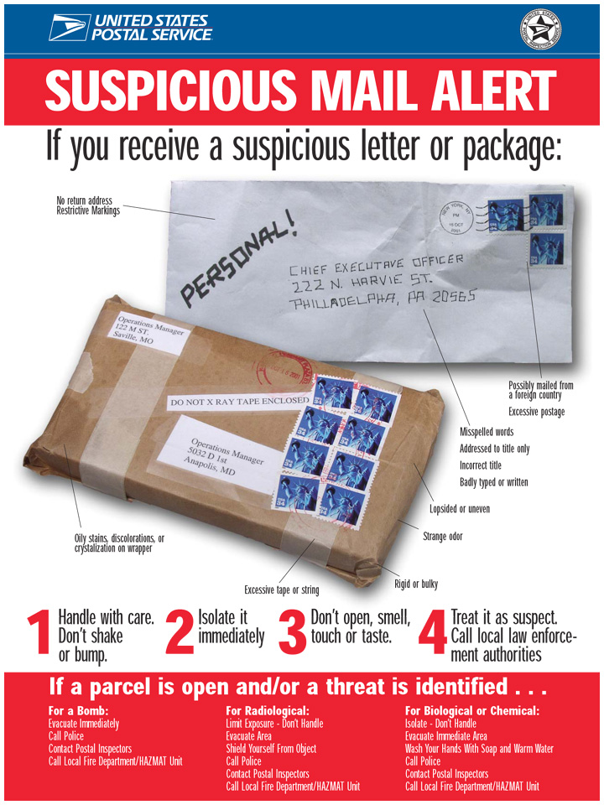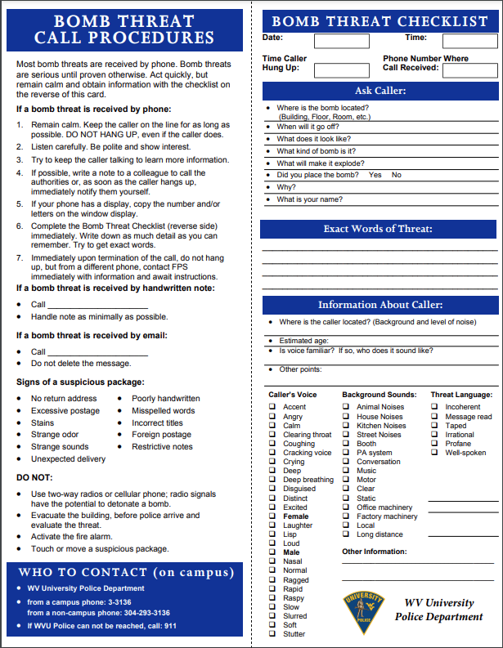 **Bomb Threats**

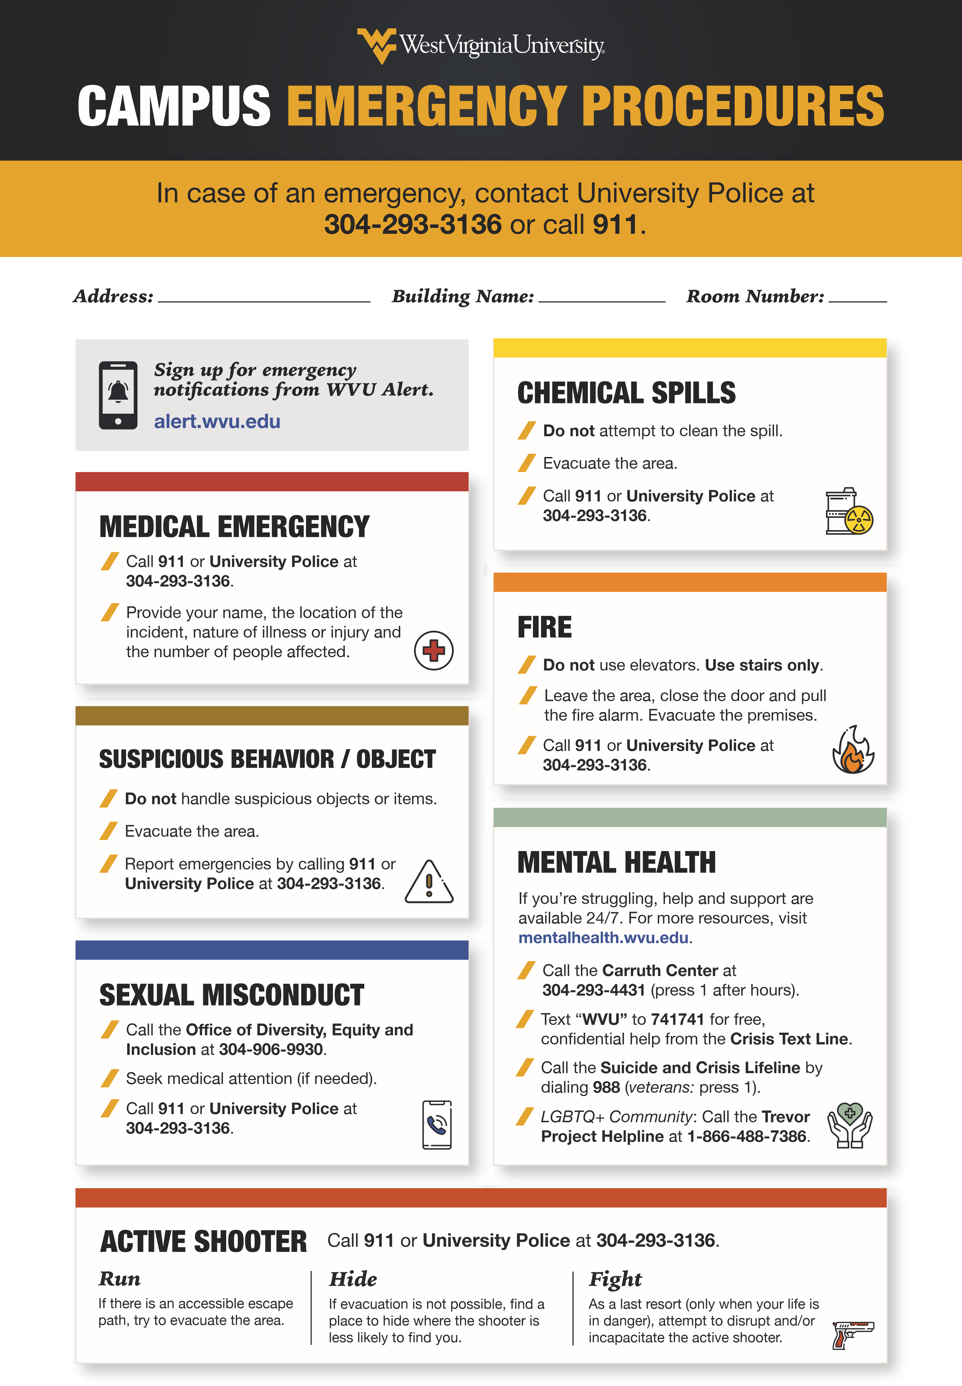

**Resources and Training**

* IS-100.c Introduction to the Incident Command System

<https://training.fema.gov/is/courseoverview.aspx?code=IS-100.c&lang=en>

* IS-906 Workplace Security Awareness

<https://training.fema.gov/is/courseoverview.aspx?code=IS-906&lang=en>

* IS 907 Active Shooter. What you can do
* Active Shooter Response WVU Police, provided in person by request at Police.wvu.edu

<https://training.fema.gov/is/courseoverview.aspx?code=is-907&lang=en>

* IS 700.b An introduction to the National Incident Management System

<https://training.fema.gov/is/courseoverview.aspx?code=is-700.b&lang=en>

University Police also provides various other in-person training and safety presentations. To schedule a training or find out additional information visit police.wvu.edu

INSTRUCTIONS FOR COMPLETING THE BUILDING

EMERGENCY PLAN TEMPLATE

This Building Emergency Plan (BEP) serves as a valuable resource to identify the specific equipment and processes within your building. It aims to provide essential information to both the building occupants and emergency responders who may need to render assistance during an emergency. Your participation in this plan involves providing relevant information on the cover and pages 1, 2, 3, 4, and 5. The remaining pages of this document are dedicated to equipping you and your building occupants with the necessary knowledge for emergency scenarios.

Should you require any assistance in completing this document or have any inquiries, please feel free to reach out to Joshua Cook at the WVU Office of Emergency Management. Joshua Cook can be contacted via email at [Joshua.cook@mail.wvu.edu](mailto:Joshua.cook@mail.wvu.edu) or by phone at 304-293-3136.

To ensure a comprehensive Building Emergency Plan, please follow these instructions:

1. Enter the specific information related to your building into the designated text form fields.
2. Once you have completed your Building Emergency Plan (BEP) and it has undergone review by your department head, kindly send an electronic copy to [Joshua.cook@mail.wvu.edu](mailto:Joshua.cook@mail.wvu.edu).
3. The next crucial step is to put the program into action. Distribute the BEP to appropriate members of your department or building.
4. Please be aware that the BEP requires annual review and should be revised whenever changes occur.
5. The BEP serves as a supplement to the WVU Emergency Operations Plan. www.Police.wvu.edu

By adhering to these instructions and actively participating in the Building Emergency Plan, you contribute to the safety and preparedness of your building and its occupants.